[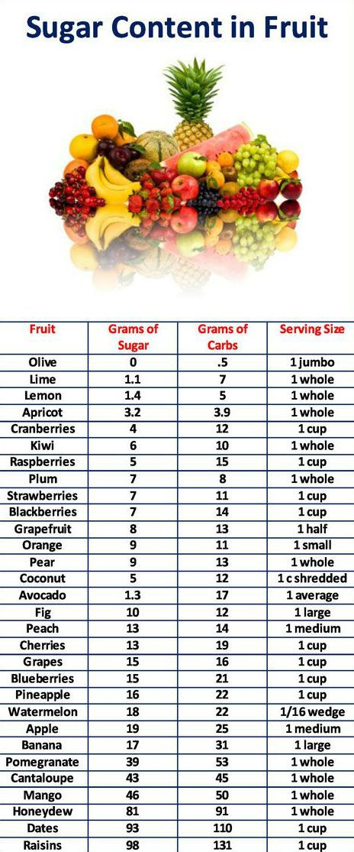](https://www.google.co.nz/url?sa=i&rct=j&q=&esrc=s&source=images&cd=&cad=rja&uact=8&ved=2ahUKEwip-dHLg_ngAhUUU30KHZloCt4QjRx6BAgBEAU&url=https%3A%2F%2Fwww.pinterest.com%2Fpin%2F40250990403902427%2F&psig=AOvVaw2q-PiBiryu-wGItf_e9S8v&ust=1552357258427360)