[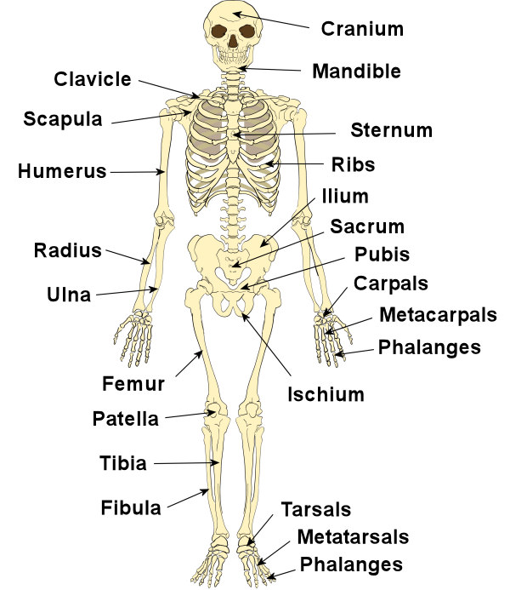](http://www.google.com/url?sa=i&rct=j&q=&esrc=s&source=images&cd=&cad=rja&uact=8&ved=0ahUKEwjv2tOhrJLZAhWDUrwKHYpCCmwQjRwIBw&url=http%3A%2F%2Feasyscienceforkids.com%2Fall-about-human-bones%2F&psig=AOvVaw2olT9LraVNCyIOdf_FloF4&ust=1518042798772168)