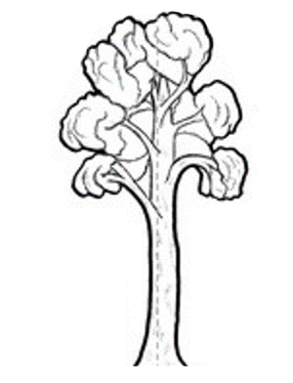
CHILD HEALTH TEAM
Ngā Kura Hauora

Ngā Kahikatea

Newsletter Messages June 2019
Each month we offer a selection of messages that you can copy / use / edit / re-style and include in your school newsletter. The idea is to support the work that you are doing in the classroom and on the playing field with positive messages that are going home.

Do you know about DIABETES?
Diabetes is the result of the body not creating enough insulin to keep blood glucose (sugar) levels in the normal range. Everyone needs some glucose in their blood, but if it’s too high it can damage your body over time.
In type 2 diabetes, either the body doesn’t produce enough insulin, or the cells in the body don’t recognise the insulin that is present. The end result is the same: high levels of glucose in your blood.
For many people (but not all) type 2 diabetes can be prevented by making healthy food choices and staying active.

You can get information about Diabetes, and order copies of this recipe book from https://www.diabetes.org.nz/understand-type-2-diabetes

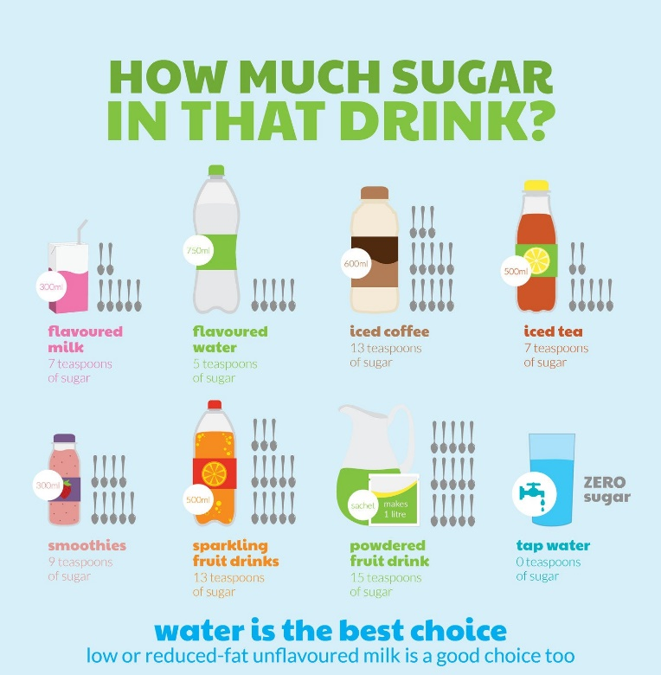
We are proud to be a Water Only School because we recognise that water is the best drink. Youngsters need plenty of water to keep hydrated but they certainly don’t need the sugar and caffeine that are in so many other drinks.

Please support us in our efforts to keep tamariki healthy by cutting down on the fizzy at home and listening to your children if they want to explain to you why water is the best drink. You’ll be caring for their teeth AND their waistlines!

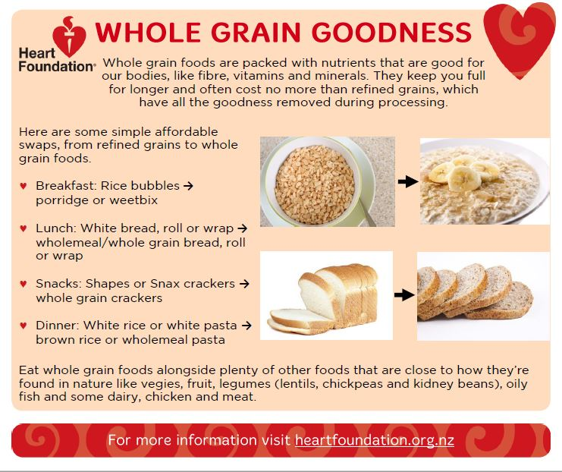

Core strengthening is essential for the progression of nearly all other developmental skills. The core is the center of control for everything else the body does! It’s difficult to balance, perform coordinated movements on both sides of the body, sit up straight in a chair, hold a pencil, control scissors, or jump if you don’t have a strong core. We know that decreased core strength commonly contributes to delayed motor skill development.
We encourage families to support children to strengthen their core.

Active transport
When was the last time you walked, biked or scooted somewhere instead of hopping in the car?
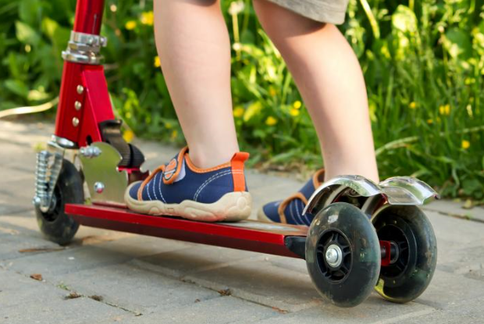
Using active transport in place of shorter car trips is a great way of fitting some activity into your day. Here are some ideas for adding a bit of active transport into your week:
- choose to walk, cycle or scoot for car trips shorter than ten minutes
- for longer trips, try driving part of the way then parking and walking a bit further then you usually would
- aim to bike or scoot the kids to school one extra day a week

“Ngā Kahikatea” – a tree endemic to NZ that was previously widespread on the Heretaunga Plains. The tree is associated with concepts of standing tall and straight whilst mutually supporting one another at the roots. Like our tamariki in their communities and schools.

