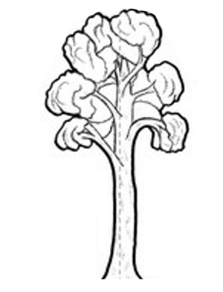
CHILD HEALTH TEAM
Ngā Kura Hauora

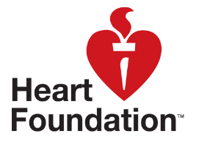

Ngā Kahikatea

Newsletter Messages April 2019
Each month we offer a selection of messages that you can copy / use / edit / re-style and include in your school newsletter. The idea is to support the work that you are doing in the classroom and on the playing field with positive messages that are going home.

Water is the Best Drink – children need to stay hydrated at school so that they can enjoy getting exercise and so that their brains are ready for learning. But drinks containing a lot of sugar or caffeine just hype the children up. Sugary drinks are also contributing to tooth decay and NZs increasing problem of childhood obesity. At school we only allow children to drink water (and milk). Please support our policy in the drinks that you offer at home.

Exercise Every Day – at school we know that children need to be active throughout the day to help their bodies to grow healthily and to freshen the brain for learning. Please encourage your children to exercise at home every day.

Sleep is the Best Medicine – young bodies need their rest. Here’s how much: 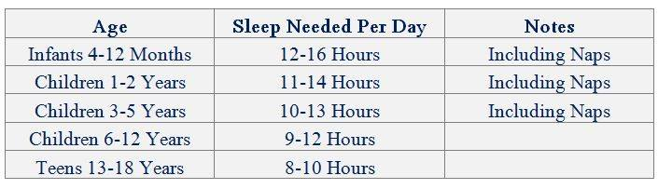

Screen time – at school we have some essential rules to manage the amount of time that children spend on their screens. You could have similar rules at home. Here’s one to try:
Get everyone to turn their phones to silent at meal times so that you have some uninterrupted time together as a family.

The Food Pyramid – children are learning about what to include (and what to cut down) in a healthy diet. This updated food “pyramid” could help you to continue the conversation at home:
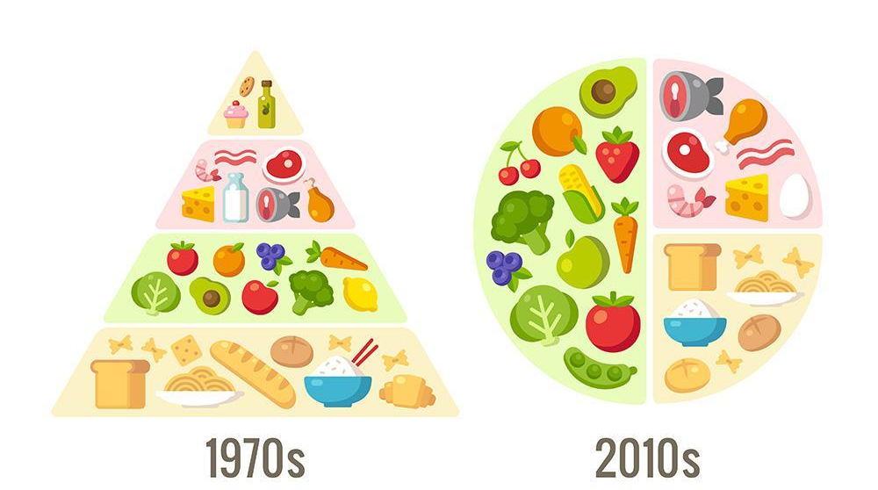

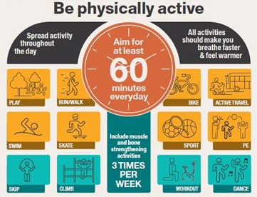

Active Fun - Build regular and FUN physical activity into your family routines:

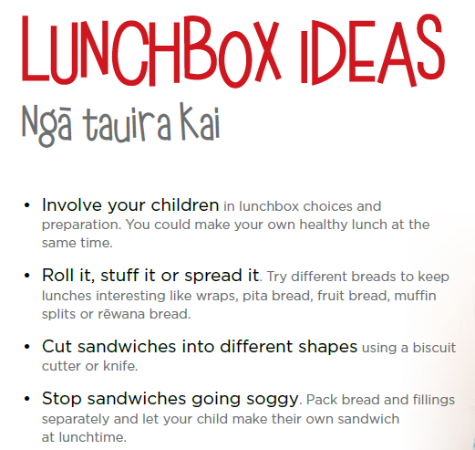

Eating Well – Many families struggle for ideas for school lunches. Try these tips: they are from the website of LearnByHeart – you can Google it.

“Ngā Kahikatea” – a tree endemic to NZ that was previously widespread on the Heretaunga Plains. The tree is associated with concepts of standing tall and straight whilst mutually supporting one another at the roots. Like our tamariki in their communities and schools.

