GROWTH MINDSET

[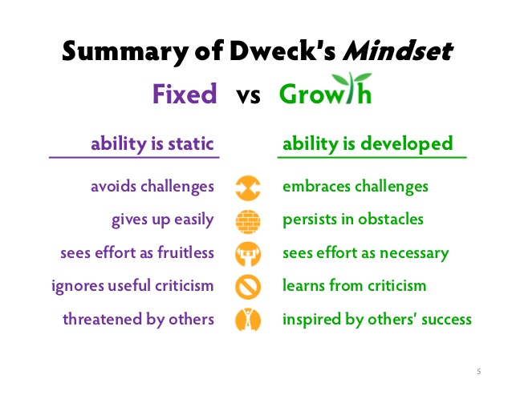](https://www.google.co.nz/url?sa=i&rct=j&q=&esrc=s&source=images&cd=&cad=rja&uact=8&ved=0ahUKEwjO7868yKXWAhVCkpQKHQfcATwQjRwIBw&url=https://www.pinterest.com/pin/218846863120076451/&psig=AFQjCNGD3nU6pZFU8x08USVS0x346sr1cg&ust=1505508962122971)Google “Growth Mindset” or Dr. Carol Dweck

1. **1. Help children understand that the brain works like a muscle,** that it can only grow through hard work, determination, and lots and lots of practice.
2. **2. Don’t tell students they are smart, gifted, or talented,** since this implies that they were born with the knowledge, and does not encourage effort and growth.
3. 3. Let children know when they demonstrate**a growth mindset.**
4. **4. Praise the process.** It’s effort, hard work, and practice that allow children to achieve their true potential.
5. **5. Don’t praise the results.** Test scores and rigid ways of measuring learning and knowledge limit the growth that would otherwise be tapped.
6. **6. Embrace failures and missteps.**Children sometimes learn the most when they fail. Let them know that mistakes are a big part of the learning process. There is nothing like the feeling of struggling through a very difficult problem, only to finally break through and solve it! The harder the problem, the more satisfying it is to find the solution.
7. **7. Encourage participation and collaborative group learning.** Children learn best when they are immersed in a topic and allowed to discuss and advance with their peers.
8. 8. **Encourage competency-based learning**. Get kids excited about subject matter by explaining why it is important and how it will help them in the future. The goal should never be to get the ‘correct’ answer, but to understand the topic at a fundamental, deep level, and want to learn more.

[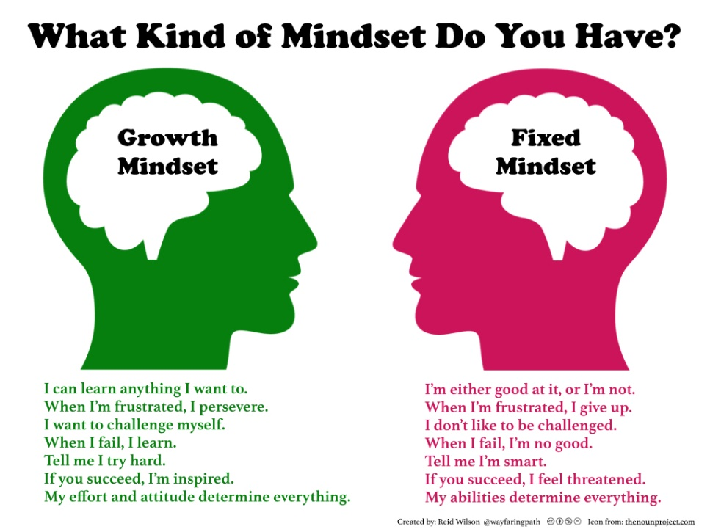](https://www.google.co.nz/url?sa=i&rct=j&q=&esrc=s&source=images&cd=&cad=rja&uact=8&ved=0ahUKEwikh_7Bm6HWAhWJn5QKHVRRBrIQjRwIBw&url=https://www.pinterest.com/pin/406590672590848234/&psig=AFQjCNEwbBRpzz83is502xTMBcTvZAhnRA&ust=1505359562374160)

[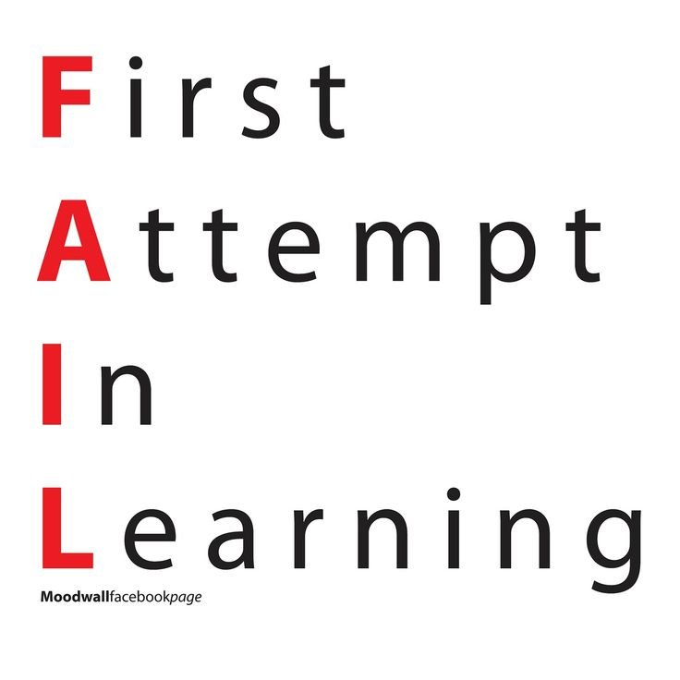](https://www.google.co.nz/url?sa=i&rct=j&q=&esrc=s&source=images&cd=&cad=rja&uact=8&ved=0ahUKEwicpuvCyaXWAhUCVbwKHTC-AYYQjRwIBw&url=https://www.pinterest.co.uk/mandyhouston64/growth-mindset/&psig=AFQjCNGD3nU6pZFU8x08USVS0x346sr1cg&ust=1505508962122971)[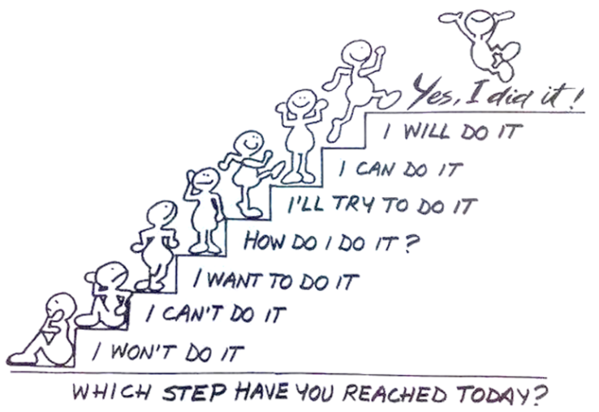](http://www.google.co.nz/url?sa=i&rct=j&q=&esrc=s&source=images&cd=&cad=rja&uact=8&ved=0ahUKEwj_v7O0nKHWAhWCULwKHWJsC48QjRwIBw&url=http://www.thebestofteacherentrepreneurs.net/2015/07/whats-growth-mindset.html&psig=AFQjCNEwbBRpzz83is502xTMBcTvZAhnRA&ust=1505359562374160)