Application form for booking Health Education Resource Kits 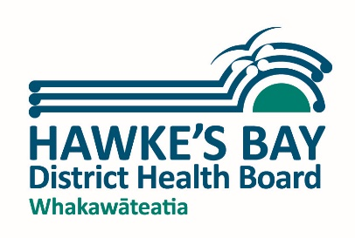

Date of application ………………..………………………………

Name of Organisation/Unit/Dept

……….………………………………………………………………………………………………………………………………………………

Contact person name: ……….…………………………………………………………………………………………………………..

Contact phone number: ………………………………… email: …………………………………………………………………..

Dates required From: ………………………………. To: ……………………………………...

Where is it being used and purpose (eg expo at Pettigrew Green, awareness week promotion in school):

……………………………………………………………………………………………………………………………………………………….

Kits required
…………………………………………………………………………………………………………………………………………………………

…………………………………………………………………………………………………………………………………………………………
Terms for borrowing items:
- I/we agree to pay any costs incurred in the event of damage, theft, fire or other loss
- I/we agree to collect and return items to Napier Health, 76 Wellesley Road, Napier, between 7.00am and 11.45am Monday, Tuesday, Thursday or Friday
- To be used by health professionals for education purposes only
- I/we agree to notify if any faults are found
- Bookings need to be made at least a week in advance and will be on a first come first served basis
- Failure to return items on time or abide by the above terms may result in exclusion from using items in the future

Please sign below if you agree to these terms and email back to resources@hbdhb.govt.nz

Name …………………………………………………………………………………………………….

Signature ………………………………………………………………………………….

