Digestive and Muscular System weblinks

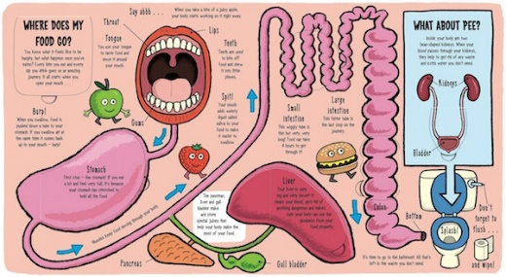
http://coolmompicks.com/blog/2015/04/14/my-amazing-body-book/
Graphic designed for children to understand where the food they eat goes. A better understanding of how the body works and the importance of food.

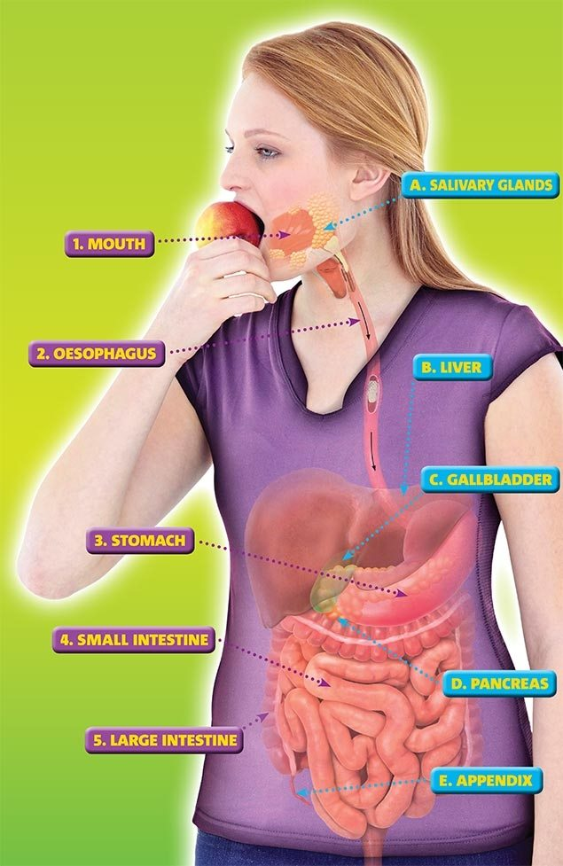
https://www.natgeokids.com/uk/discover/science/general-science/digestive-system/#!/register
This is what happens to your food after you eat it. Understand the reason food keeps us alive and helps us grow, develop and think.
This is an interactive site from National Geographic.

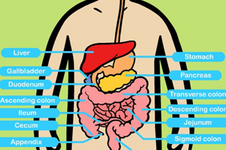
http://sciencewithme.com/page/13/?attachment_id
Science with me provides information on what happens to your food once you have eaten it.

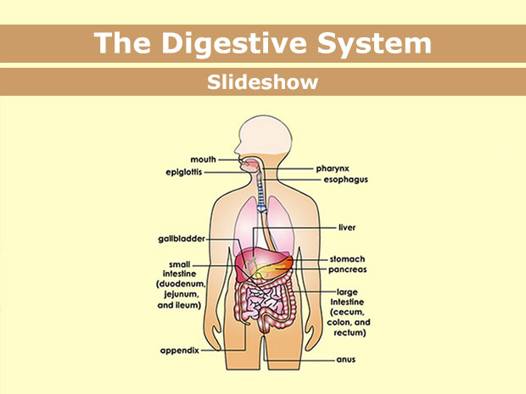
http://kidshealth.org/en/parents/digestive.html
Kids health is a New Zealand site for parents with a range of information of health issues mainly aimed at weight of children. With a visual slideshow of the digestive system and a description on its function children can learn by seeing and reading.

https://www.youtube.com/watch?v=ohZU4d39k5A
Watch and learn about the digestive system. What happens to the different foods you eat?

https://www.youtube.com/watch?v=d082RVFdLi4
Watch and learn through this visual trip through the digestive system.

https://www.youtube.com/watch?v=ZeUlh9Cou38
Watch and learn about how your digestive system works and what it does.

https://www.youtube.com/watch?v=s06XzaKqELk
Crash course in biology, get a rundown of the way your body works once you have eaten food along with some really interesting facts about the human body.

http://digestivesystemforkids.com/worksheets/
From crosswords to word finds to fill in the blanks and even colouring in, these worksheets are a fun way to educate children on the digestive system.

https://thehomeschoolscientist.com/science-saturday-the-digestive-system/
Do your own experiment and become a scientist and discover the inner workings of your digestive system.

http://digestivesystemforkids.com/15-fun-facts-digestive-system
15 fun facts about the digestive system

MUSCULAR SYSTEM: https://thehomeschoolscientist.com/science-saturday-muscle-notebooking-with-apologia/

https://www.visiblebody.com/learn/muscular/muscle-movements
Watch and learn about the muscles and joints in the body and how they work to allow us to move.

